Warehouse Inventory Application

Rushilkumar Patel (1716695)

Sapanaben Makadia (1716708)

Keyur Lakhani (1724817)

Fairleigh Dickinson University, Teaneck, NJ 07601

**Sequence Diagram**

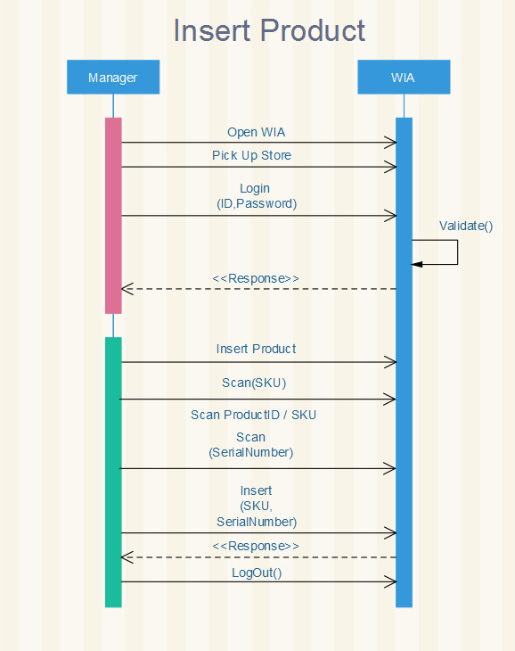

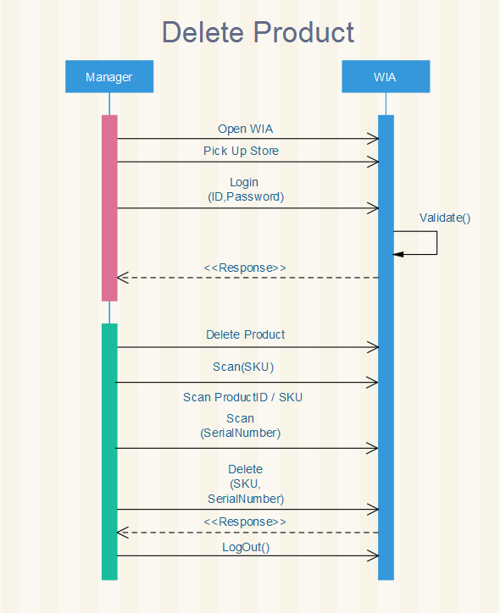

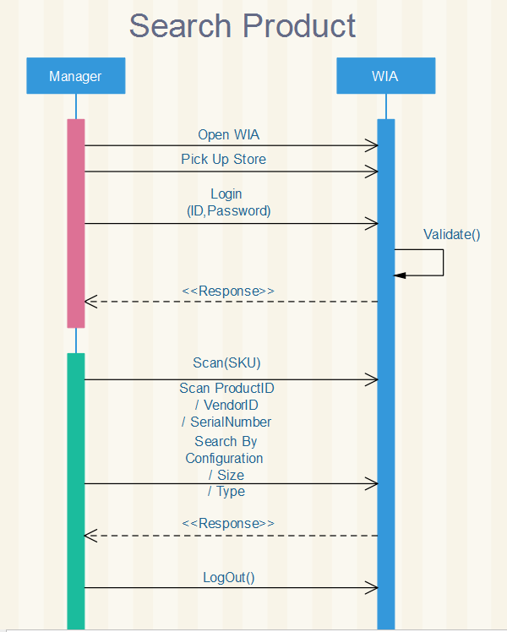

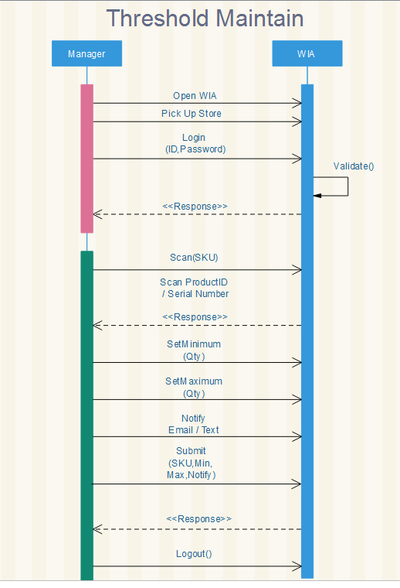

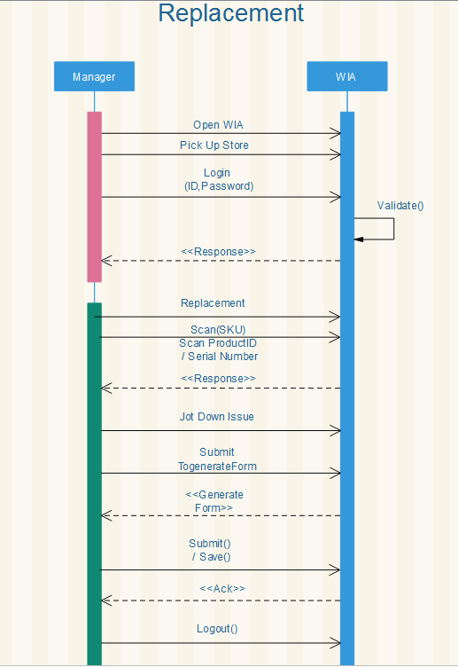

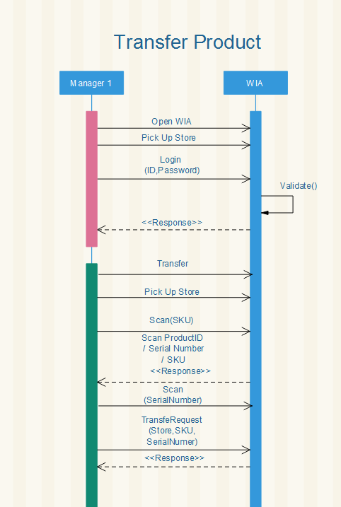

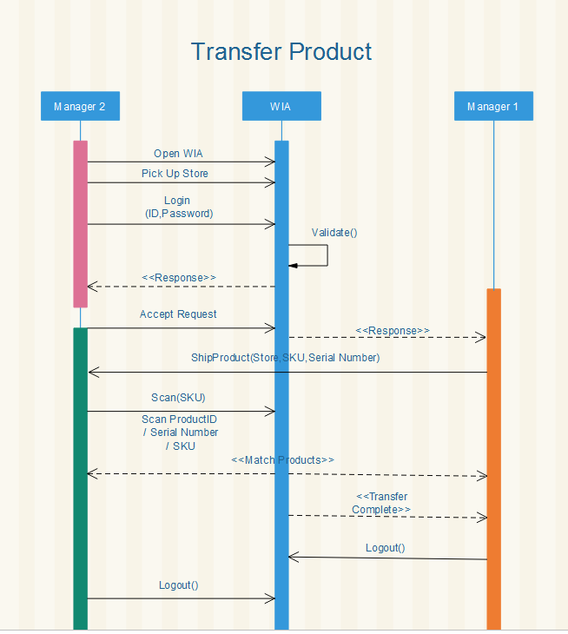

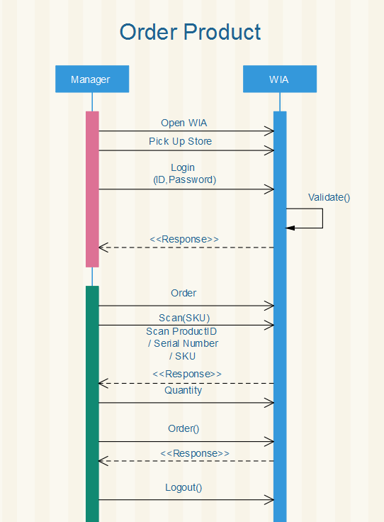

**System Design**

Project Goals:

1. It has the better user interface and application is being easy to use.
2. This application works on all the device which has the internet connections working on the device.
3. All user has its own unique id and password which is been registered with the user email id.
4. Application is being reliable that can insert, update and delete product in the warehouse.
5. Application also maintains the threshold level in the warehouse system.
6. It adds, delete or update any product in database with 5 seconds.

Boundary Object:

1. Admin can define privilege accesses to the users.
2. WIA can notify the user about threshold level, order, replacement.

Object Model:

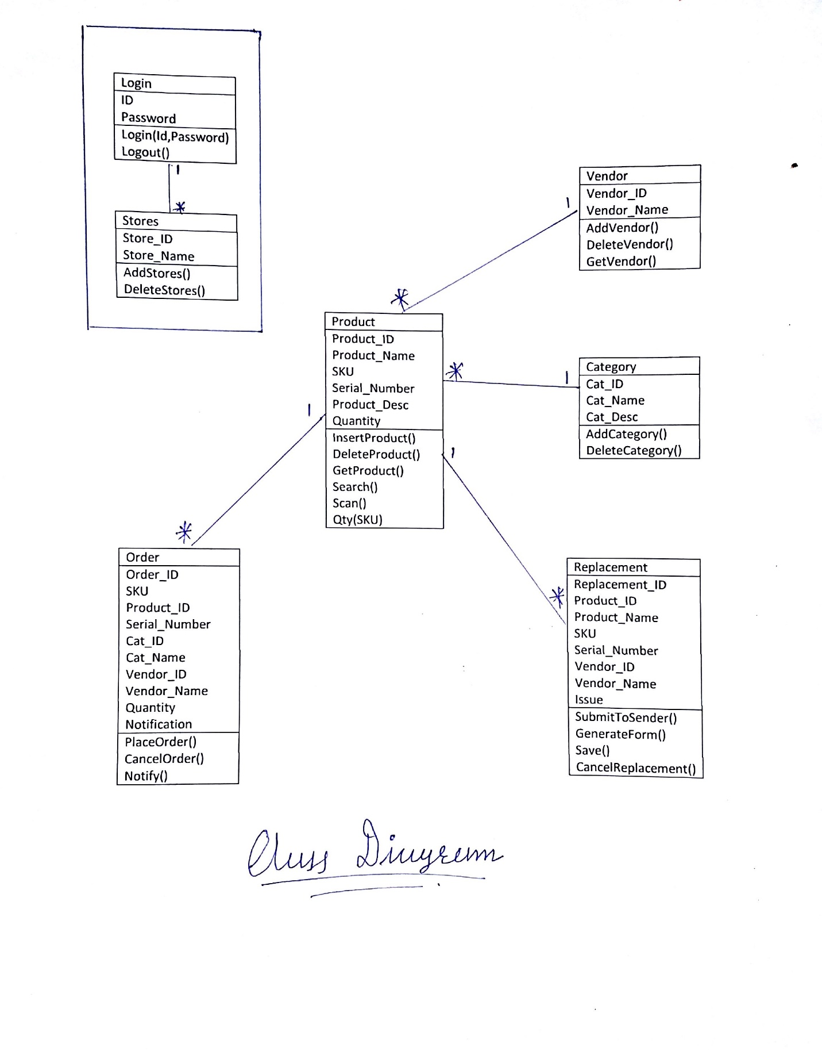

System Decomposition:

* High Coherence.
* Low coupling.

Subsystems:

1. User
   1. Admin can define privilege accesses to the users.
2. Product
   1. All the operation related to the product like insert, delete, update, order replacement and threshold is being done on the subsystem.

Data Management:

1. Data is being stored for a year in the database and once the item is being released from the warehouse, the data for the same product is been transferred to the file system to optimize the performance of the WIA and related data mining operations.
2. If the product is not being released from the warehouse for more than a year, then the product item is being popped up in the system and ask the admin for future steps.